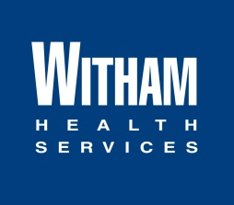

Is your organization a 501 (c) 3? Yes

No

*September 2022*

No

Yes

I have attached art guidelines and advertising specs specsIhave attached art guidelines and advertising specs

Check should be mailed to:

Artwork should be sent to:

Check should be written to:

Phone Number: Email:

Contact Name:

Requesting Organization

Please list all sponsorship benefits, including but not limited to: advertisements, program recognition, banners, etc.

How does your request meet the criteria in the sponsorship guidelines?

*(Include name* & *address)*

*(Example: Pens, brochures, first-aid kits, etc.)*

In-Kind Items

What type of sponsorship/donation are you requesting? Please complete each area that applies.

Dollar Amount

For **internal** use **only**

Date Received _______

Received by _________

Group/Population Served Number Served

*(Example: Women, Children, Individuals suffering from diabetes, etc.)*

Event Location Event Date

Program/Event Name   
 *(Examp1e: Diabetes Walk, Youth Football League, Breast Cancer Awareness, etc.)*

**GENERAL INFORMATION**

Date Sponsorship Request Submitted: ____________________________

If you have any questions, please check with the Marketing Department at 765-485-8107.

Please **submit the request by Due Date**

If your event or sponsorship occurs January 1 – June 30 **Submit Request by November 1** **deadline**  
If your event or sponsorship occurs July 1 - December 31 **Submit Request by May 1** **deadline**

**INSTRUCTIONS**

Please be sure to read Witham Health Services Sponsorship Guidelines. You must fill out the form completely for your request to be considered. You may attach additional correspondence if you wish.

Witham Health Services Sponsorship Form